VT STORMWATER MANAGEMENT

FACT SHEET
Collecting & Disposing of Wastewater
This fact sheet outlines best management practices regarding the proper collection and disposal of wastewater from campus activities including Dining Services, Housekeeping, and Research Laboratories.
Potential Pollutants:

- Pathogens
- Excess Nutrients
- Chlorine Compounds
- Hazardous Chemicals
- Cleaning Products
- Fats, Grease, Oil

Containment Methods:

- Equipment or material washing should be performed in a designated wash area designed to collect and hold wash water before discharging it into the sanitary sewer system. (See Photo 1).
- Contain wash water using absorbent socks or other containment methods if NOT in a designated wash area.
- Conduct any cleaning of oily materials, steam cleaning, or pressure washing inside a building or on a contained area, such as a containment pad. (See Photos 2 and 3).
- Collect wastewater in watertight storage containers, preferably with a firm-fitting lid.
- Wastewater with no hazardous chemicals may be directed to the sanitary sewer system – if hazardous chemicals are suspected, DO NOT wash down the sanitary sewer, contact EHS (540) 231- 3600 for further guidance and pickup.

Disposal Methods:

- All equipment and materials should be washed in the aforementioned designated areas.
- Wash water that does NOT contain toxic chemicals, may be disposed into the sanitary sewer system.
- If outdoor cleaning is absolutely necessary, wash equipment, materials, or containers over flat, grassy/pervious areas and away from watercourses and storm drains.

Pollution Prevention Tips:

- If floor drains are present, verify that they are not connected to the storm sewer system.
- Oil and grease should always be recycled and never dumped down storm drains or on the ground.
- Place waste materials/wash water inside rigid, durable, watertight and rodent proof containers with tight fitting covers. Storage containers should be regularly inspected and kept in good condition.
- Toxic waste includes used cleaners, rags (soaked with solvents, floor cleaners, and detergents) and automotive products (such as antifreeze, brake fluid, radiator flush, and used batteries).
- Work sites should remain clean.
- Cover, repair, or replace leaky dumpsters and compactors. Rain can wash oil, grease and other substances into storm drains.
- Wash greasy equipment such as vents and mats in designated wash areas.

NOTE:

Any hazardous chemicals (toxic, corrosive, flammable, reactive, and heavy metals) CANNOT be disposed in the sink, contact Environmental Health and Safety at (540) 231-3600 for pickup.

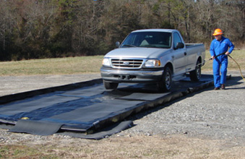
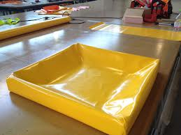
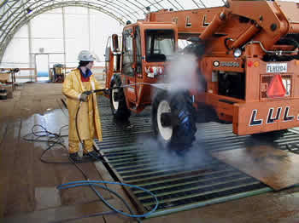
Photo 2: Example of a drip pan for use in laboratories and/or vehicle maintenance areas.
Photo 1: Example of a containment pad.

Photo 3: Example of a containment pad.

